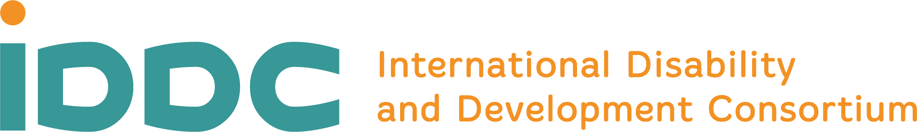

IDDC European Union Task Group
10 May 2024

What IDDC Thinks About EU’s Plans for Working with Other Countries

What is IDDC?
IDDC is a network.
This means a group of different organisations that work together.
We focus on the rights of people with disabilities.
IDDC works on inclusive development cooperation.

Development cooperation is when people from different countries work together to help make things better in communities that need it.

Usually, it means people from countries that have more money give that money to countries that need it.
The money is used to help solve different problems, like making sure that people have clean water or that all kids can go to school.

When we say that development cooperation is inclusive, that means people with disabilities fully take part.

And IDDC also works on inclusive humanitarian action.

Humanitarian action means helping people who need help right away because something happened in their community.
For example, they might need help because there is a war or a flood where they live.

IDDC members help people in these situations, and want to make sure that people with disabilities are also getting help when they need it.

Who is the European Union and the European Commission?
The European Union is a group of 27 countries in Europe.
They agreed to work together and help each other.
The European Union funds many projects outside of Europe that are important for people with disabilities.
The European Union also makes laws that are important for inclusive development and humanitarian action.
The European Union has 3 main parts:
- the European Commission
- the European Parliament
- the Council of the European Union
The European Commission is the part that writes laws for the European Union.

What is happening?
IDDC is worried about new plans from the European Commission.
These plans are not public yet.
We know about these plans because someone inside the European Commission shared these plans without permission. This is called a “leak.”
IDDC read the plans and is worried about what they say.

What do the European Commission’s new plans say?
The plans are about the money that the European Union uses to help other countries.
They want to use the money that is supposed to be about helping other countries to work more with businesses.
They want to use a programme called the Global Gateway Initiative to do this.
Working with businesses more would help the European Commission to make more money.
IDDC thinks these plans to work with more businesses do not care enough about treating everyone equally or protecting people’s rights.
The new plans do not say anything about protecting the rights of people with disabilities.
The plans shows that what is important to the European Commission is to make money when working with other countries.

What is IDDC’s main worry?
IDDC believes that the new plans put too much focus on making money.
This might ignore the needs of very poor people and harm our planet.

What does IDDC want?
IDDC wants the European Commission to change its plans.
IDDC does not want the Europe Commission to use the money that is meant for helping people to work with businesses.
IDDC believes that it is important for the European Union to work together with other countries.
IDDC believes that the European Union and the other countries should focus on:
- helping people to have a better life.
- respecting people’s rights.
- protecting our planet.

Why is this important?
The European Commission is important because they help solve big problems in the world.
If they are thinking more about money and business than helping people, then they will not be helping to solve the world’s big problems.
It is the job of organisations like IDDC to speak up when things are happening that will not respect people’s rights.

